1. **Enable cloudtrail monitoring and store the events in s3 and cloudwatch log events.**

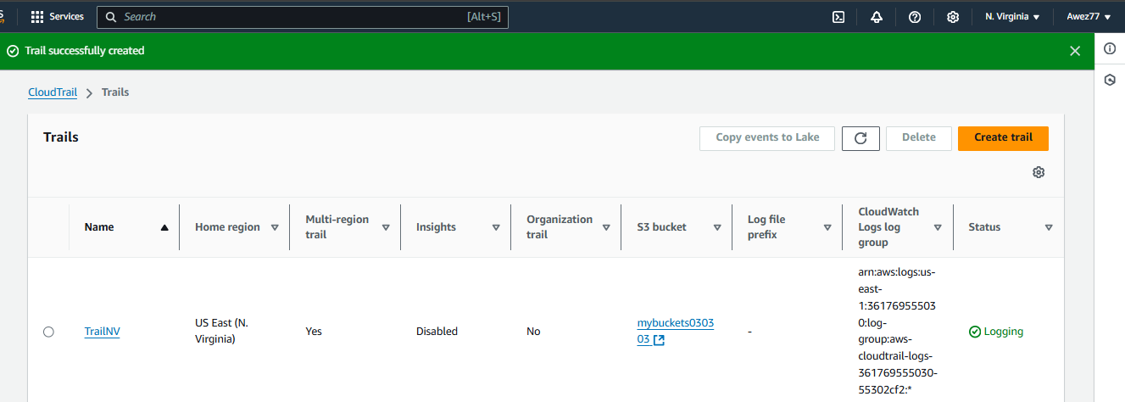

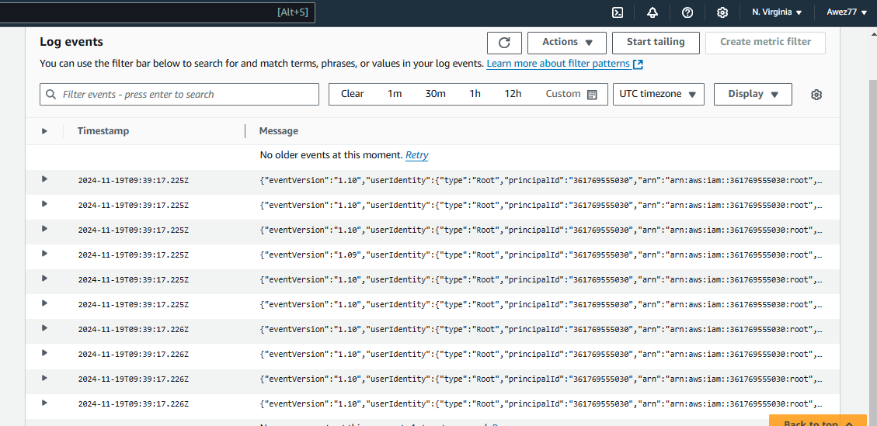

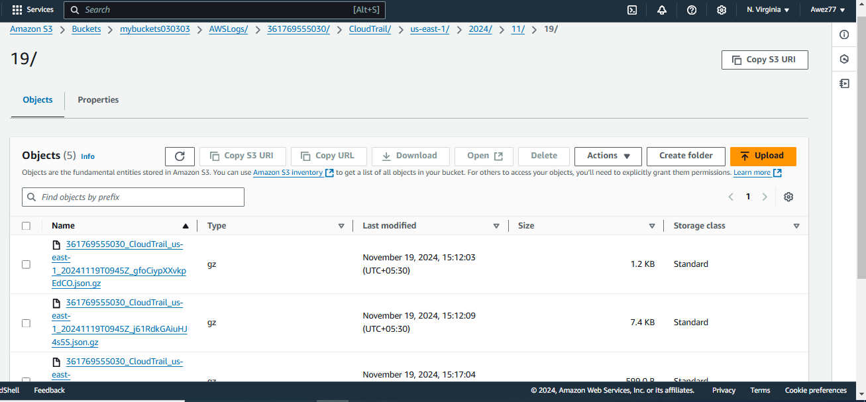

1. **Enable SNS for cloudtrial to send alert on email.**

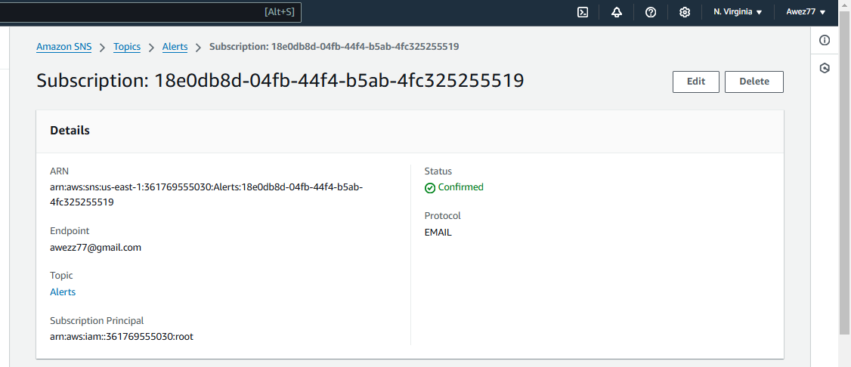

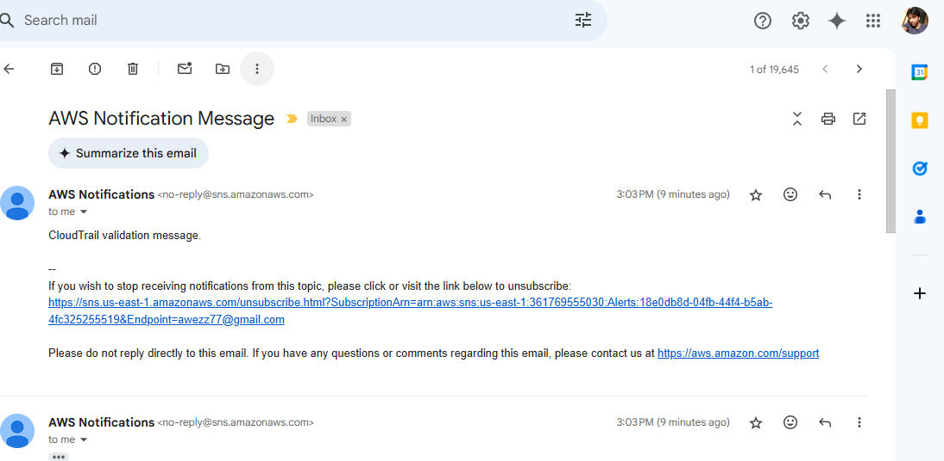

1. **Configure cloud watch monitoring and record the cpu utilization and other metrics of ec2.**

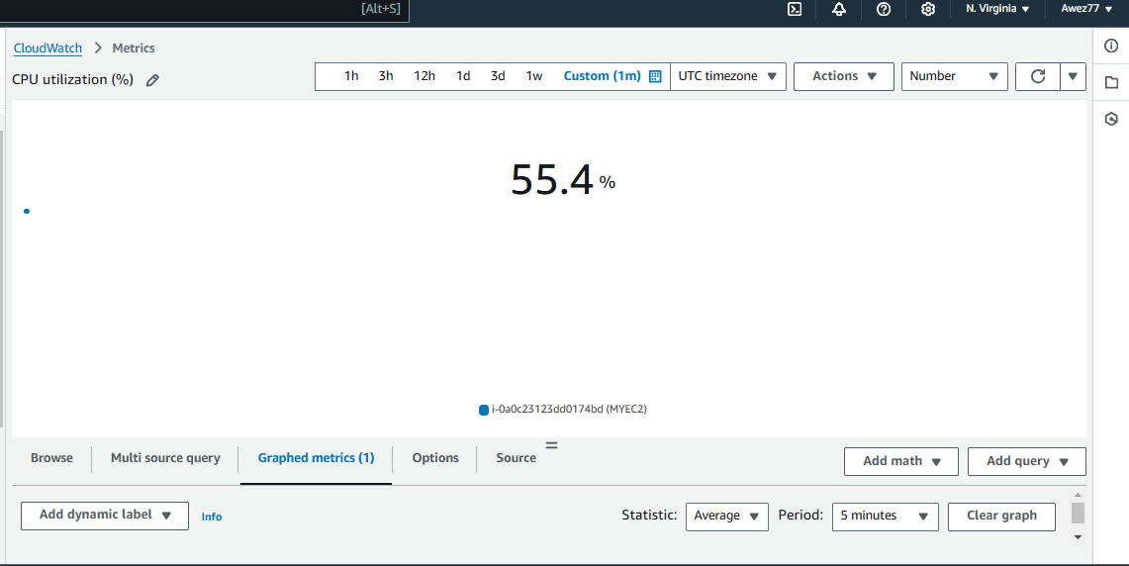

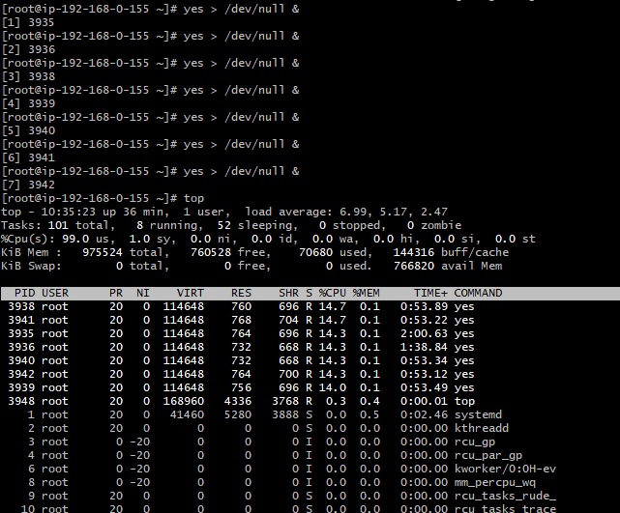

1. **Create one alarm to send alert to email if the cpu utilization is more than 70 percent.**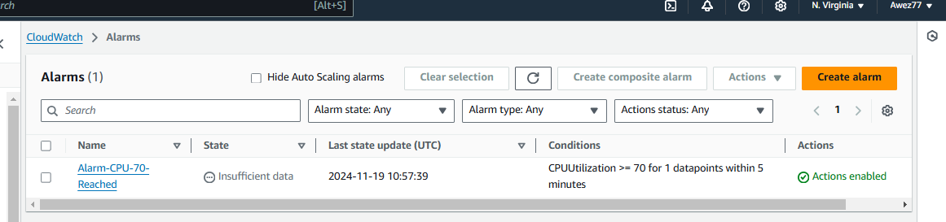

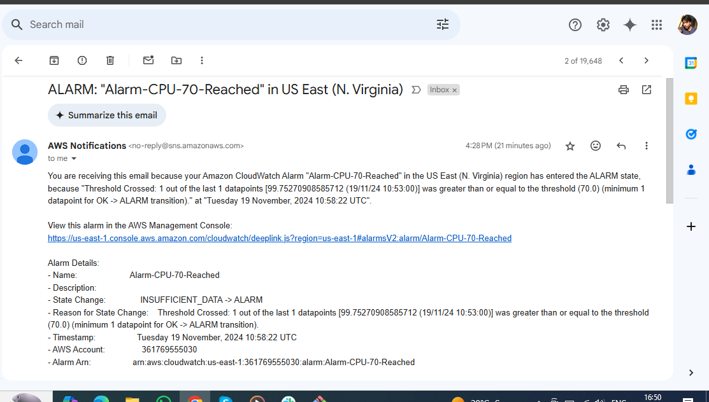

1. **Create Dashboard and monitor tomcat service wether it is running or not and send the alert.**

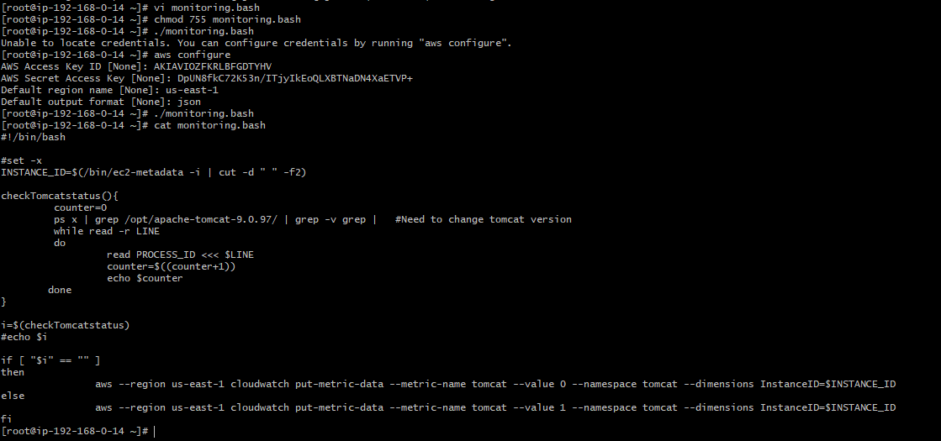

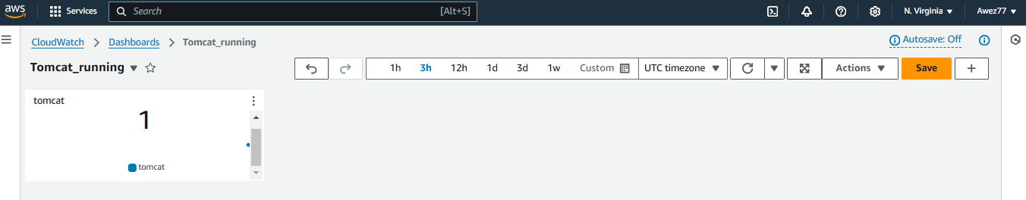

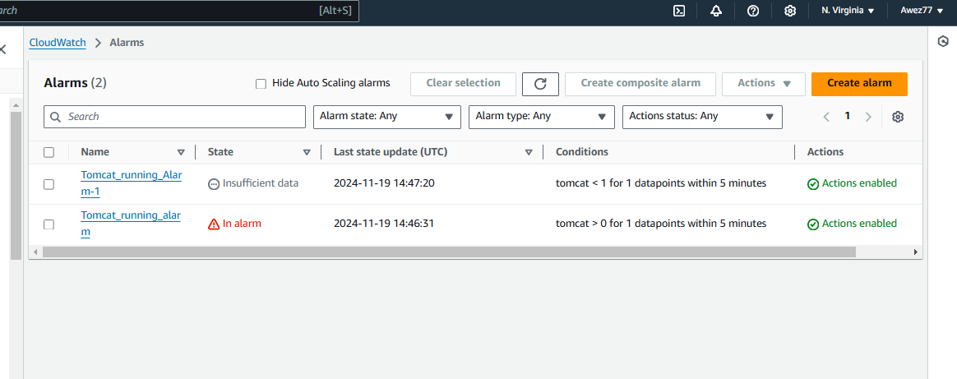

**6) Create Dashboard and monitor nginx service to send the alert if nginx is not running.**